1. Paper 1 Question 8

(a)(i) 255 = max, min = -256

(ii) sum(n) = 2^n -1

0<= n <= 32

(b)(i) topics should be a TreeSet, since the topics are stored alphabetically, and Tree Set automatically stores items by alphabetical order

Messages should be a LinkedHashSet, since it maintains insertion order, which the program wants

(ii)

public void addTopic(String name) {

topics.add(new Topic(name));

}

public List<String> displayMessages() {

List<String> output = new LinkedList<>(); //Linked List since it keeps insertion order

for (Message m : messages) {

output.add(m.display());

}

return output;

}

(iii) The observer Pattern is used

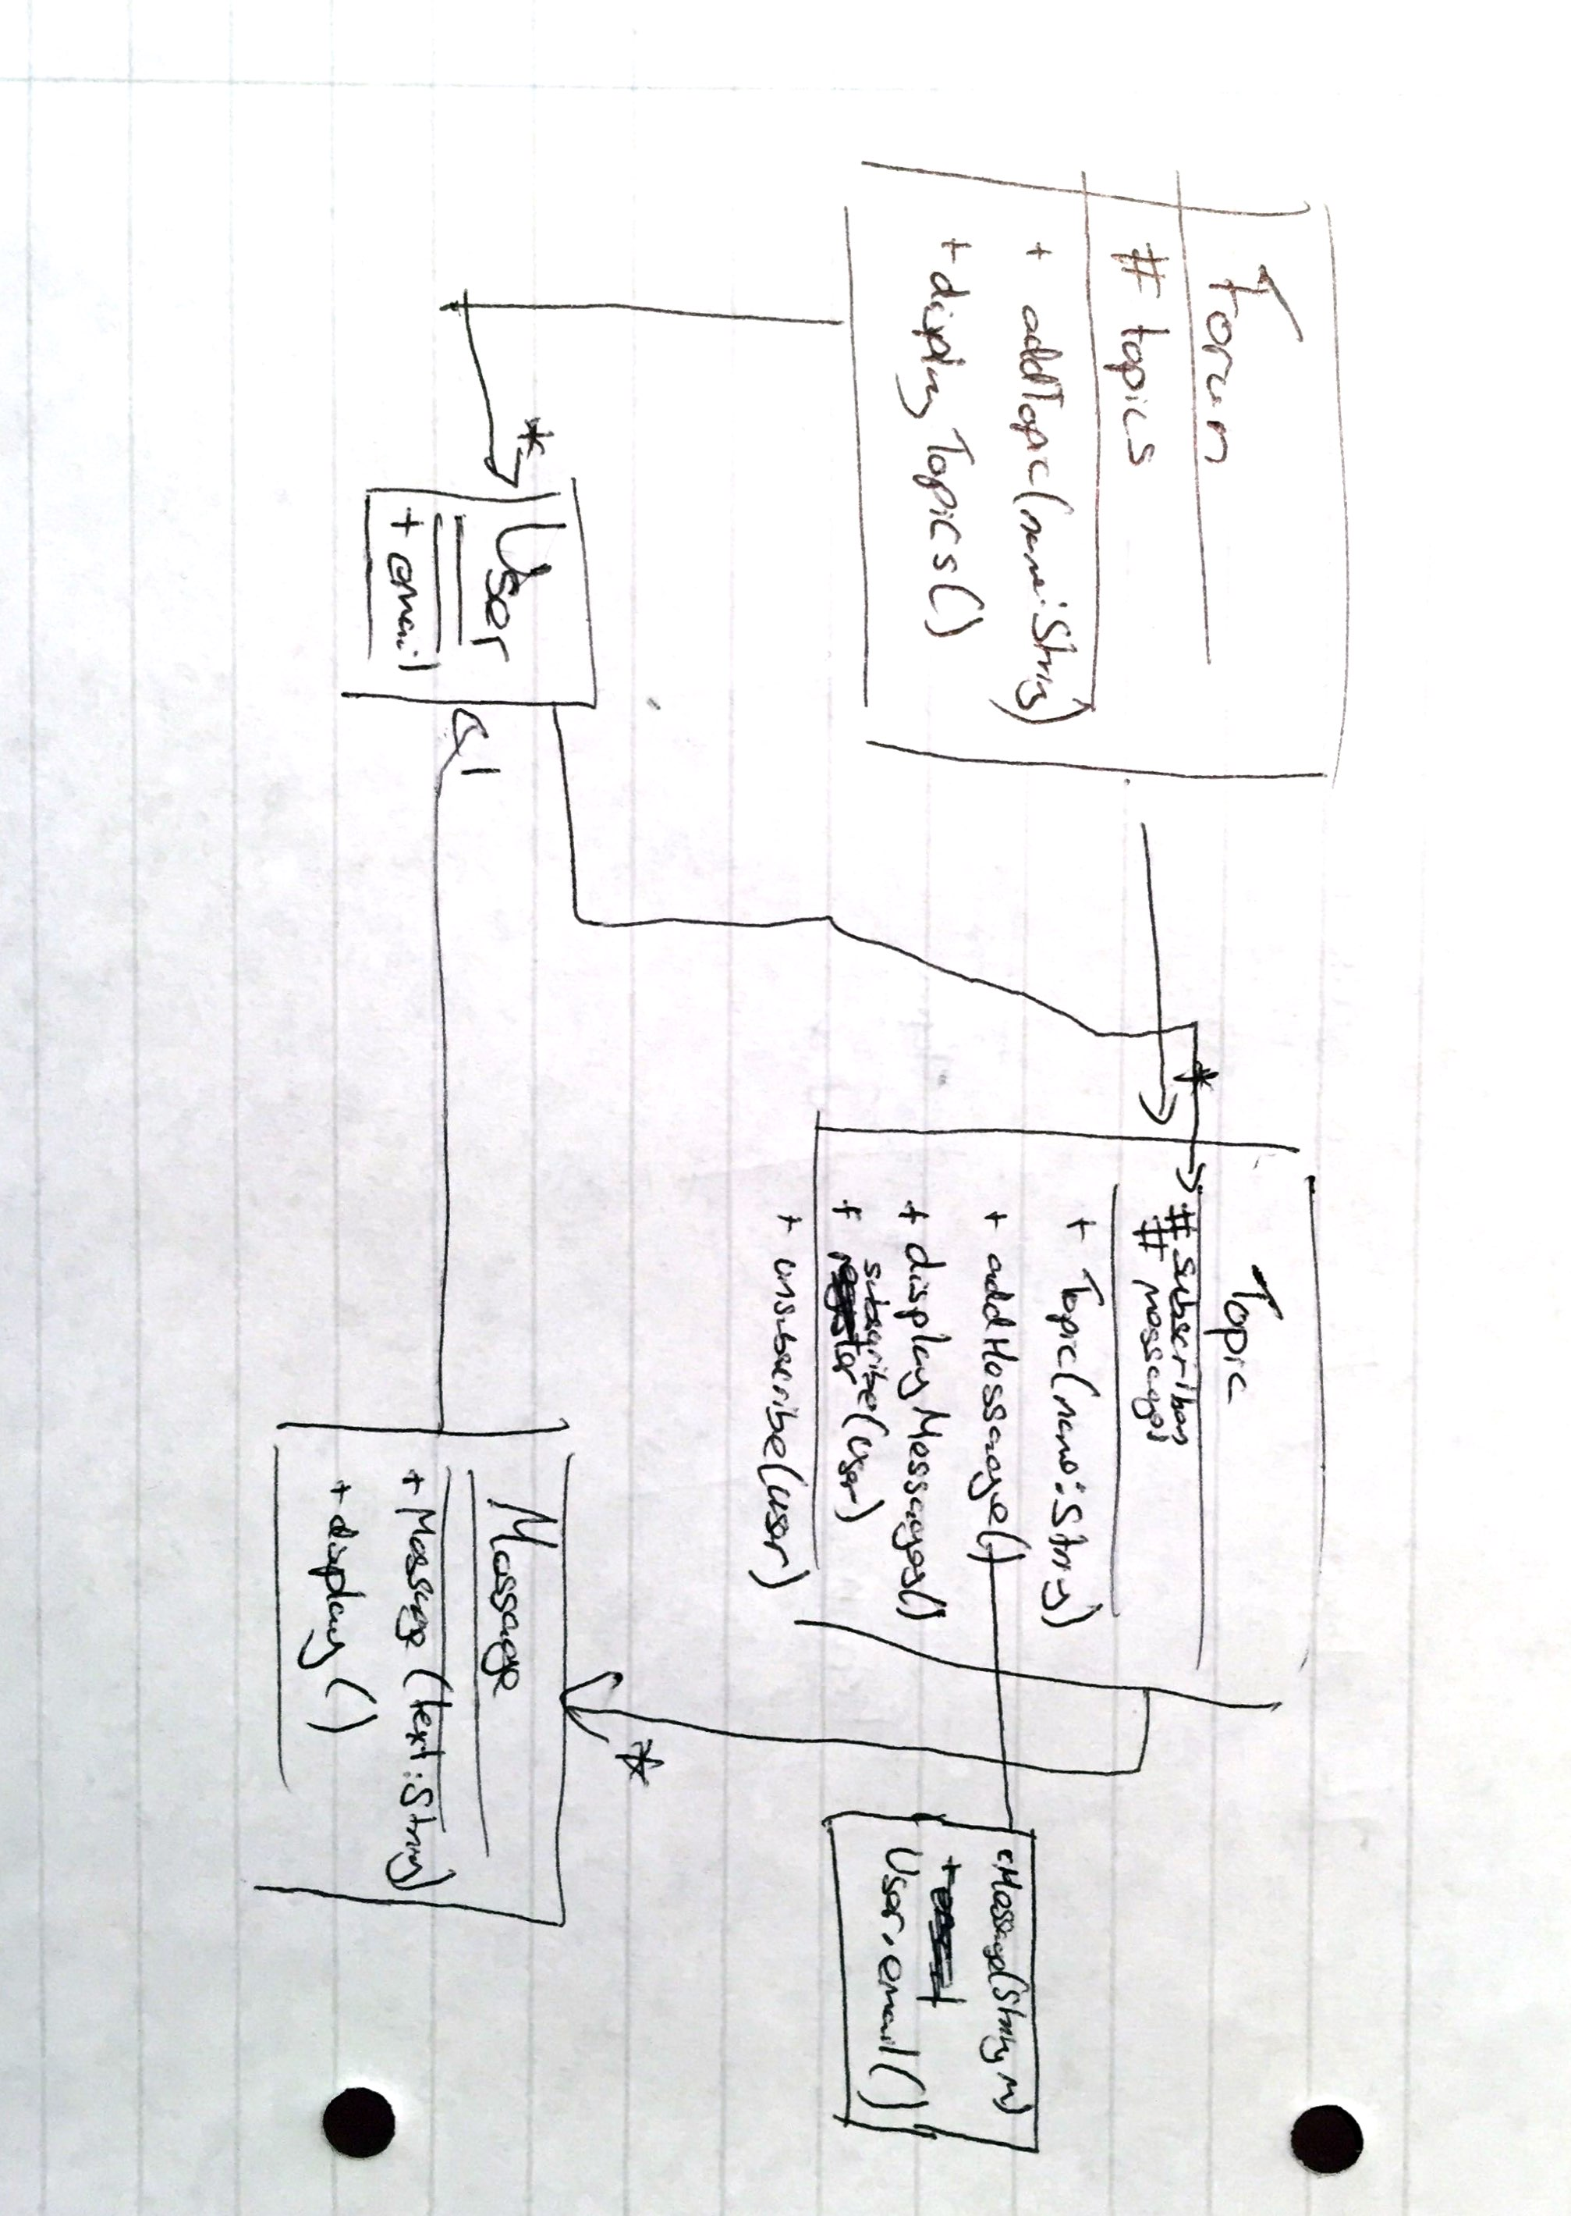

1998 Paper 3 Question 3

1. A class is java is made up with methods which describe its functionality and variables which describe its state, with a constructor which initialises the object. In Java the inheritance system allows the user to create an object which has all the functionality of a class but with some more detail. This is done by the inheritance system, which allows a class to inherited the parent class.

The *new* operator instantiates an object by assigning memory to the new object, for this it requires an object constructor.

The class constructor has the job of initialises the object. The constructor itself just assigns things to variables determined by its arguments.

An object is finalised when the JVM determines that no other object has contains the reference to it therefore it is useless. Then the garbage construct calls finalize() and the object is disposed.

1. Abstract Classes are classes which can contain variables, methods and abstract methods. They cannot exist as objects but are used as such that other normal classes can extend them and their functionality. Interfaces are such that they contain variables and methods but the methods must be undefined. This makes interfaces as good guides for class planning, as classes are able to implement multiple interfaces. This guarantees that a coder doesn’t forget to add functionality to the class.
2. The modifiers determine how identifier can be seen. The public modifier means that the identifier can be accessed by the world. Private means that only the class can see it. Protected means that the package and subclasses can see it. You can also get other modifiers, but these have no effect on the visibility of identifiers.

1998 Paper 1 Question 3

1. >>> is an operator which shifts the pattern to the right by a certain amount and replaces the far left digits with 0. E.g. 1010>>>2 = 0010. >> is a signed version of >>>, it does the same thing but if the number is negative it keeps it negative by placing the digits as 1, and if positive it replaces with 0. E.g. 1010>>2 = 1110.
2. (a==a) may return false with some objects. As with objects “==” works by comparing the reference of the object. So if there are 2 identical objects with different reference ie one is the clone of the other (a==a) will read false
3. Final is used in class construction – it means a class cannot be inherited, method cannot be overridden, a variable cannot be changed. Finally is used as part of a try-catch block. It is a block which will executed the code regardless of any exception is handled or not.
4. “three” is a string, 3 is an int. They are types of primitives. Unfortunately, the + operator only works with variable of the same type. Therefore the expression will not compile since “three” and 3 are different types of primitives.
5. The array a is set to size 10 therefore it can be accessed from 0-9. In the code, the for loop goes from 1 up to including 10. This means that it will be asking access to a[10] which does not exist. Therefore there will be an ArrayOutOfBoundsException.